Voice Controlled Air Purifier & Sleep Assist

Air pollution is now a global problem and especially major cities. The air pollution levels in many cities usually reach pollution levels way beyond health air standards. Sleep deprivation is another problem that has resulted from busy schedules and stress. The solution to protect ones lungs while indoors lies in air purifiers.
Well here we develop a modern day air purifier which can be operated by just voice commands and also helps one sleep by playing relaxing sleep music when asked by user. The purifier is a perfect modern day air filtration unit that uses HEPA filtration with added UV to filter as well as kill any bacteria or viruses in the process.
The voice controlled air purifier provides the following advantages:
- HEPA filtration for dust & PM2.5 Pollution
- UV For Bacteria and virus killing
- Voice activated and shutoff
- Voice activated fan speed control
- Voice based pollution level notification via speech
- Voice activated sleep/relaxing music player
- Easy to use contactless operation

The air purifier achieves this functionality using HEPA filters, UV filter, Speaker Module, Mic, LCD Display, Fan, PM2.5 Sensor, Air quality Sensor and all this controlled by a raspberry Pi controller.

The system circuitry s powered by a dc power supply to run the purifier. The raspberry pi controller makes use of a microphone to listen to the users commands. The user may start or turn off the purifier by saying “Purifier Turn On” and “Purifier Turn Off”. Also the user can control the purifier fan speed as desired using voice commands.

The user can also ask the purifier to speak out the current pollution levels in the room. The system on receiving this command speaks out the current PM2.5 and air quality levels to the user via the speaker. The user may also command to play sleep music upon which the raspberry controller plays sleeping music to help user sleep. The system makes use of speaker to speak or play music to the user and the mic to listen to users voice commands.

The purifier pulls in air through the bottom and throws out filtered air through the top mesh. The raspberry pi is used to listen to user commands and operate the fan and speaker to fulfil all functions of this multipurpose air purifier.

Components:
- Raspberry Pi
- PM2.5 Sensor
- Air Quality
- Fan
- Speaker
- Microphone
- HEPA Filter
- UV Filter
- LCD Display
- Power Port & DC power Adapter
- Resistors Capacitors
- Diodes & transistors
- Buttons & Switches
- Electrical & Wirings
- PCB Board
- Base frame
- Supporting Rods
- Steel Mesh
- Connectors
- Screws and Fittings

Applications:
- Home & Offices
- Hospitals & Hotel Rooms

Advantages:
- HEPA filtration for dust & PM2.5 Pollution
- UV For Bacteria and virus killing
- Voice activated and shutoff
- Voice activated fan speed control
- Voice based pollution level notification via speech
- Voice activated sleep/relaxing music player
- Easy to use contactless operation

Disadvantages:
- It is not battery powered
- It cannot play any music requested from web

Block Diagram

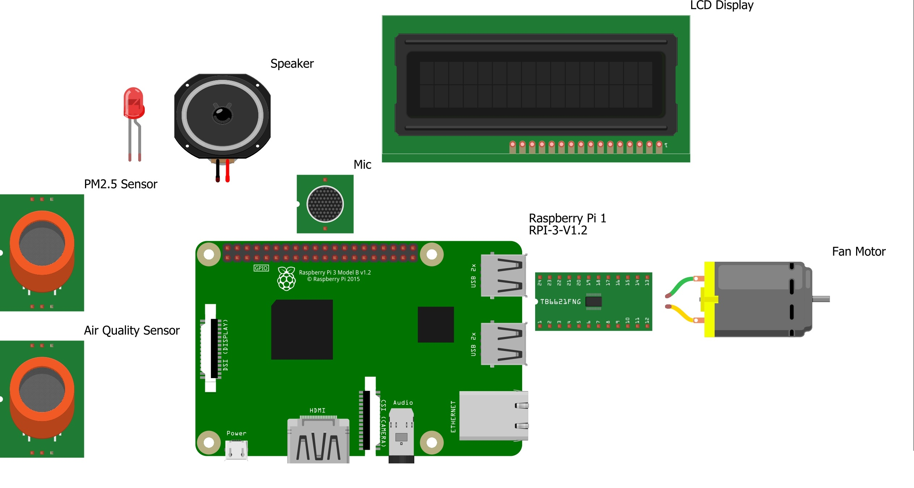

3D Designs

